St Mark’s Church Recipe Allergen Checklist DATE:____________

Check packaging of all ingredients.

Does it contain:
Menu item | 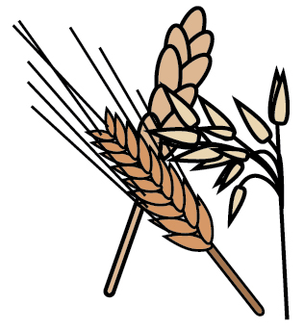 | 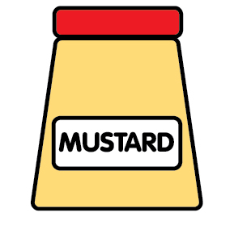 |  |  |  |  |  | 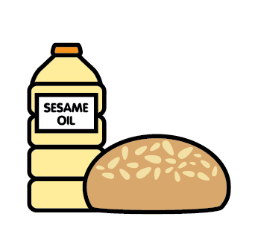
 | Cereals containing gluten | Mustard | Lupin | Eggs | Milk | Nuts | Peanuts | Sesame seeds | Soya | Celery | Fish | molluscs/ crustaceans | Sulphur dioxide

